13.6 Produkt Structure Inquiry

By using this function we can get informartion about components of our chemical products.
Means from which sub-articles we produce the final article.

Parent ItemPBOM Code: enter full article number
+ 2x Next
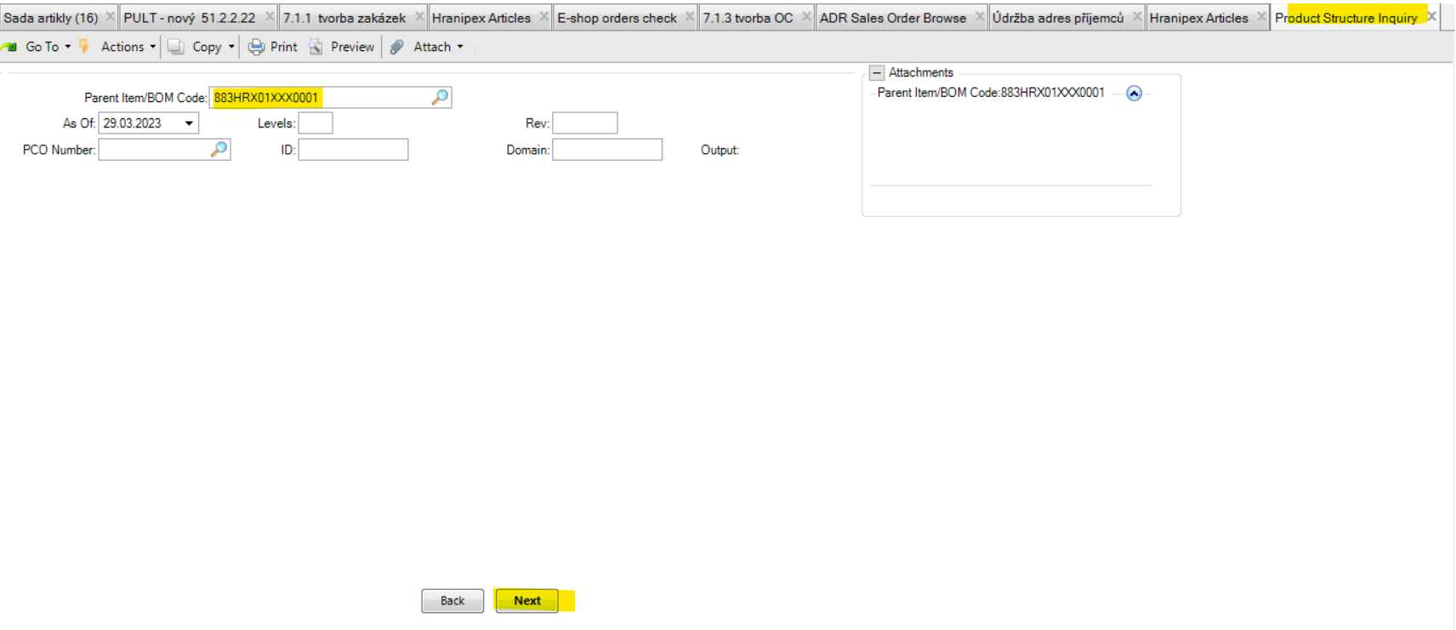

CHECK FOLLOWING PAGE.

Below we see that:
- 883HRX01XXX0001 is made from 883HRX01XXX0001E (1l package)
- then 883HRX01XXX0001E (1l package) is made from 883HRX01XXX1000E (1000l package)

So, is necessary to check availability of these products to know if we can produce and confirm 883HRX01XXX0001.

+ all other lines are saying more information about packaging (no need to check):
890V11005XX0001 = plastic bottle
ET100X100NEKLOP = eticket „do not tilt“
ET100X100OM = eticket „ADR LQ“ (limited quantity)
ETPAPETIG94250 = another eticket
KA335250265N = cardboard

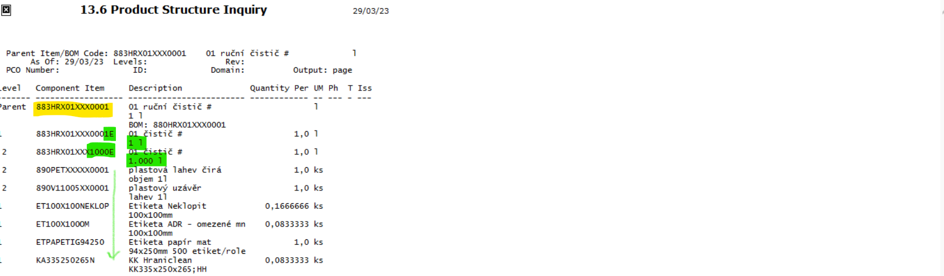

I´m checking with our IT an option that you will have access to this function in CZ domain 200. It seems to me that it should be possible.

